42.39: a) 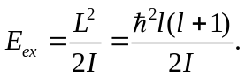
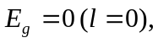
and there is an additional multiplicative factor of 2l + 1 because for each l state there are really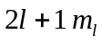 states with the same energy.

So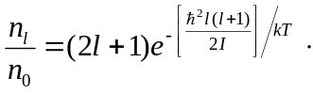

b) 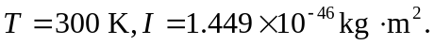
(i) 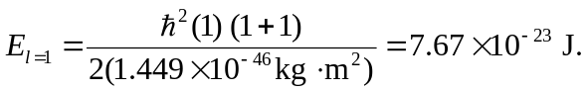
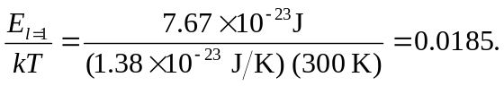
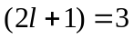
so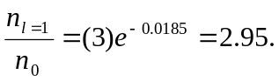
(ii) 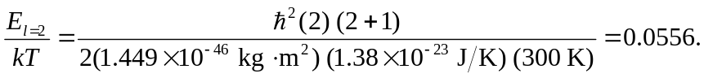

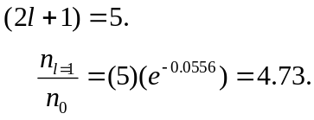

(iii) 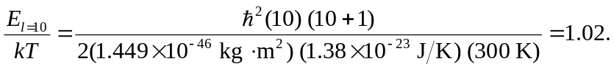 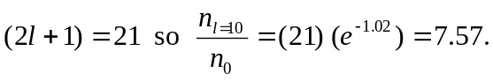
(iv) 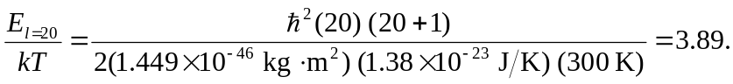
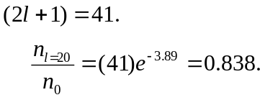
(v) 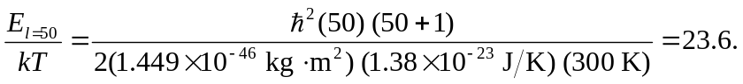 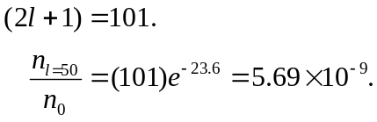
c) There is a competing effect between the (2l+1) term and the decaying exponential. The 2l + 1 term dominates for small l, while the exponential term dominates for large l.

